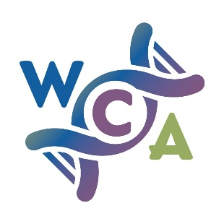
Prostate Cancer Awareness in Black Men 2021-2022
Grants Application Form (up to £500)

Person/ organisation and general project details
Name of person/ organisation making this application
Daytime telephone number
Email address
Address of person/  organisation’s main office |  |  | Postcode
Brief description of you/ your organisation, including the type of organisation (if applicable, e.g. registered charity, CIC)
Organisation’s registration number(s) (if applicable)
Project start date |  | Project end date
Your project idea

What you want to do and what will be the impact of your piece of work
(250-350 words maximum) Please tell us about what you want to do with this grant, including which communities you will engagement with, where this will be and an estimate of how many people you will reach.

COSTS BREAKDOWN
You can apply for up to £500. Please complete the table below, only including the costs for this project that is the focus of your grant application.

Please give a clear breakdown of all costs, e.g.
- Staff costs including the cost per hour and approximate number of hours to be worked
(Remember to include on-costs like National Insurance, management time etc.)
- Venue hire, advertising, refreshments, and other event-related costs
- Volunteer costs
- Other actual direct costs you expect to incur in delivering the project

Type of cost | Cost for this item | Breakdown of the cost
 | £
 | £
 | £
 | £
TOTAL COSTS | £
TOTAL SUM APPLIED FOR | £

If your project costs more than you are asking us for, please answer the two points below
How you will make up
the project cost shortfall
When you expect to have all the
funds needed for this project

Alternatively you could consider applying to Communities Against Cancer here: https://actionhampshire.org/what-we-do/projects/communities-against-cancer/

CERTIFICATION
By submitting this application I confirm that the information on this form constitutes a true overview of the project and gives a true picture of our organisation.

Full name of person submitting application
Return your application to:
england.wessexcanceralliance@nhs.net

FOR OFFICE USE ONLY
Date application received |  |  |  | Date application acknowledged
Application eligible? | YES / NO | Signature |  |  | Date
If not eligible, please explain here

